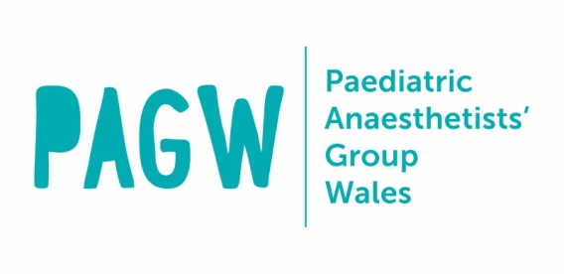
Spring Scientific Meeting 2024
10th & 11th Oct 2024

ABSTRACT DEADLINE SEPTEMBER 1st 2024

Professor Michael Rosen Prize Competition Application Form

Details of the first author of the presentation:

For staff-in-training only:
Name including title:
Job title / grade:
Hospital:
Full correspondence address:
Telephone:
Mobile:
Email:
For Medical Students only:
Name:
Medical School year:
Full correspondence address:
Telephone:
Mobile:
Email:
Hospital where work was undertaken:
Named supervisor for project (must be consultant or senior trainee ST6 or above):
Supervisor correspondence email:
Title of abstract:

Category: Quality Improvement & Audit / Case Report / Research

Details of the presenter (if different to above):

Name including title:
Job title / grade:
Hospital:

Declaration
I hereby submit my abstract to the Society of Anaesthetists of Wales for consideration of presentation at the Spring Scientific Meeting. By e-mailing the form to Dr. Danielle Huckle on sawcouncil.secretary@gmail.com or posting the form to the Society, I declare that:
- I am one of the participants in the project.
- I have read and understood the rules pertaining to the competition.
- For quality improvement / audit projects, the project has been registered with the Audit Department in the hospital(s) concerned.
- For case reports, informed consent has been obtained from the patient for presentation of the case and for any photos or images used therein.
- For research projects, approval from the local Research & Development Board has been obtained.
- No personal identifiable information relating to patients is included in either the abstract or the presentation. (The exception is for photos for which consent had been obtained.)

ABSTRACT:

